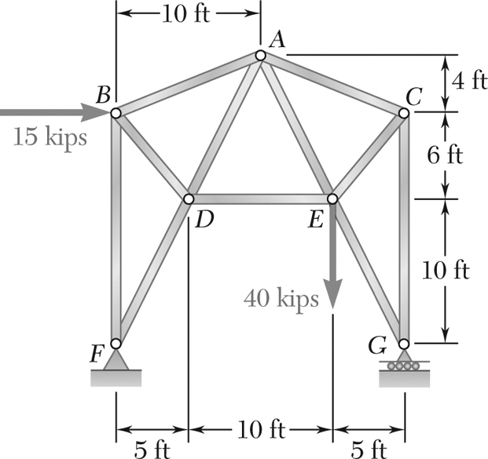

Determine the force in each of the members of the truss shown.

State whether each member is in tension or compression

**STATICS** ***UDM ENGR 3120*** - ***BUCT MEC 1701-1703*** ***CHAPTER 6 – Analysis of Structures*** Student Name……………….........

ASSIGNMENT # 6-2 Due on 16/12/19 Student # …………… Name ………………………….